Installation of splunk
a. Create account in https://www.splunk.com/.
b. Navigate to:-
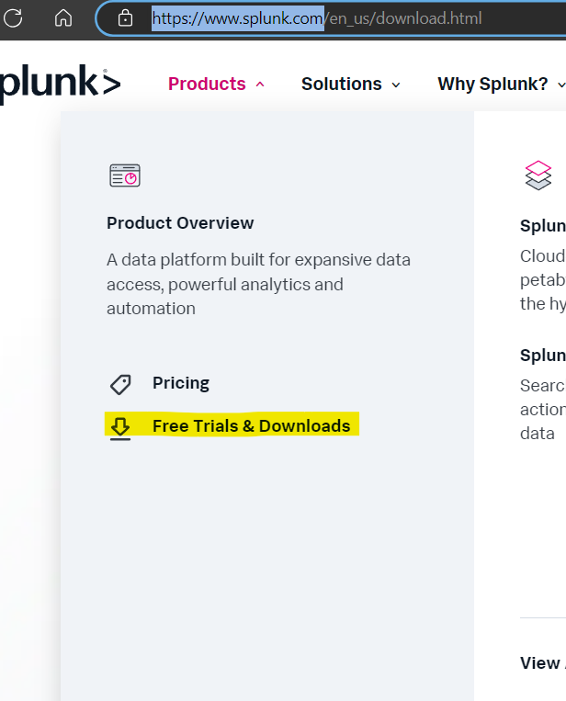

c. Select the product and click “Get my free trial”
d. Choose the OS where Splunk needs to be installed.
e. There are 2 options to download splunk via command line or direct download.
f. Once the product is downloaded into your local (in my case it’s Linux) place it in “/opt/splunk”
g. Follow the installation instruction on – Installation instructions - Splunk Documentation. For Linux environment ensure to use
‘root’ user.
h. Once splunk is installed navigate to ‘/opt/splunk/bin’.
i. Run the following command when starting the server for the first time. “./splunk start --accept-license –answer-yes”
j. Set the admin user name and password.
i. Navigate to the url displayed.
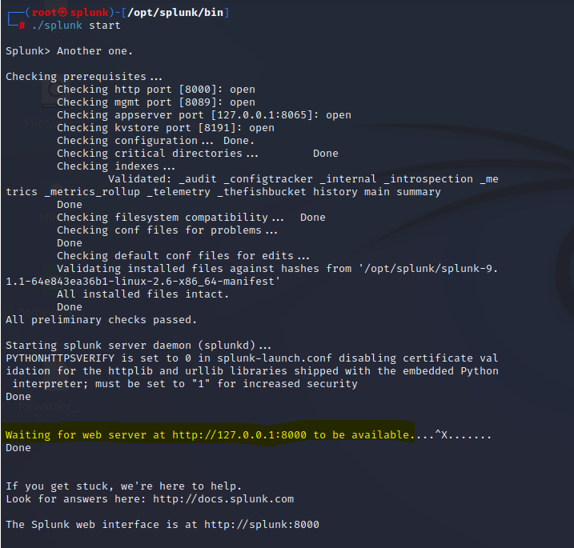

j. Enter the user name and password to login to your instance.

Note:- in case you forget admin password follow the following steps - https://community.splunk.com/t5/Community/ct-p/en-us
Stop the splunk server using ./splunk stop

Configuring universal forwarder
a. From the product page download the forwarder.
b. The installation process is same as that of splunk instance.
c. Once the forwarder is installed, for Linux navigate to ‘/opt/splunkforwarder/bin’.
d. Start the server using - “./splunk start --accept-license –answer-yes”
e. On Splunk web interface configure the reciveing the port. Settings -> forwarding and receiving -> configure receiving port.
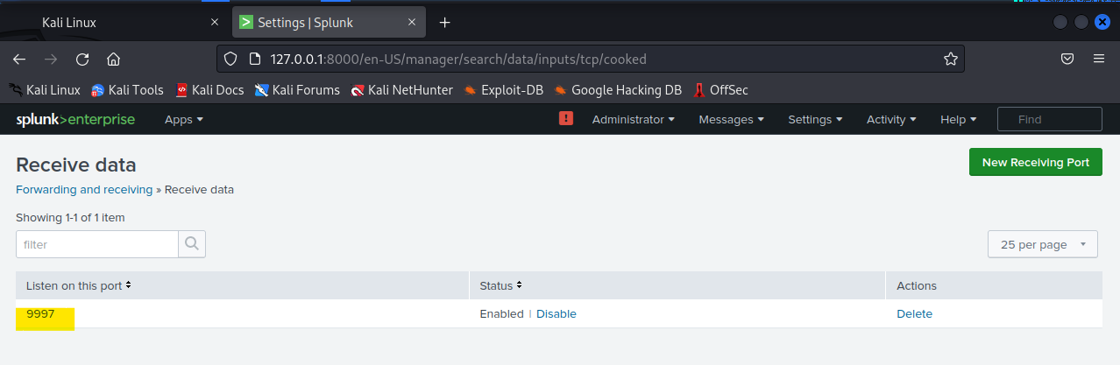
f. In the command line interface enter the following :-
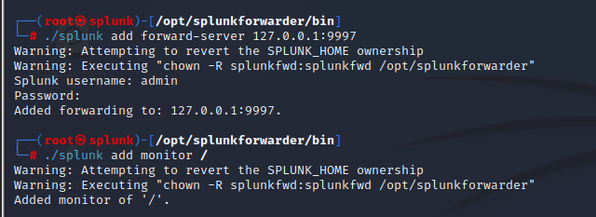

g. The following set the forwarding server as 127.0.0.1:9997
h. And it also sets the directory to monitor as the root directory of the system.
